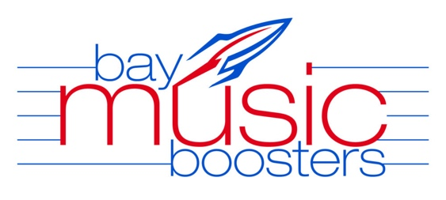
Meeting Minutes – February 14, 2024

BHS – Band Room – 7:00 pm

Attendance: Mr. Allen, Mr. Awad, Mrs. Gess, Mrs. Singler, Tracy Deibel, Sandra Larimer, Jennifer Burt, Lisa Melby, Rob Jennings, Lisa Melby

MUSIC DIRECTOR REPORTS:

BHS Bands– Mr. Allen:
- Thank you to all the volunteers
- New Xylophones being christened
- Solo Ensembles and HS Ensembles went well
  - Had 2 renowned guests on Friday that were really great! His favorite!
- Upcoming Events:
  - YSU invitational will have fancy busses need to load by 3:15
  - 2/28 Big Band Bash Concert- Special trumpet player
  - 3/5 Symphonic Band Concert
  - 4/17 Blue Jazz
  - 4/25 Classical Jazz

BMS Bands– Mr Awad:
- Thank you for all the Boosters we are very busy at the middle school
- MS Honors fest with Dir. Joss
- Pitt orch working hard on Something Rotten March 21-24th
- Upcoming Events:
  - 2/28 Big Band Bash
  - 3/6 Mid Winter Band 6th-8th gr bands
  - 3/13 Wen MS Band solo and ensemble recital
  - 3/23 Sat -all day Solo and Ensemble contest
  - 3/25 Rocky River MS Jazz Fest

BHS/BMS Orchestra – Mrs. Singler:
- Thank you
- HS Orch concert went well
- Next week Jerod Impichchaachaaha' Tate, a well renowned Classical pianist and composer will be here
- is coming He is so AMAZiNg. West Life is sending a reporter to do a story. Fabulous experience!
- MS is transitioning to recital prep, all students learning performance psychology
- HS Solo and Ensemble wrapped up everyone worked real hard
- Upcoming Events:
  - 2/23-24 HS state orchrestra
  - 3/19 Stings recital

BMS Choral Dir – Mr. Novak:
Sent email
BHS Choral Dir – Mrs. Gess:
- In choir land everything going well- thank you Boosters
- Show Choir has picked a new dress
- Upcoming Events
  - OMEA Friday and Saturday
  - 3/4 Choraleers performing at Cavs game
  - 3/8 Accapella and Treble concert
  - 3/26 All district Winter Choir Concert

Rockettes – Coach Baumgartner:
- Reviewing new uniform ideas.

OFFICER REPORTS:

President – Tracy Deibel:
- Welcome to Valentines addition of the Boosters
- Stressed the need for Volunteers for Committees and Chairs
  - Uniform Committee
  - Blitz decorating Committee
  - Recording Secretary
- Starting planning for the Blitz
- Uniforms
- Welcome to Sandra Larimer who is filling in for Tricia Rhea as treasurer

Treasurer – Tricia Rhea/Sandra Larimer
- Tricia has to take a personal leave from treasurer duties and Sandra Larimer is filling in
- Mable’s Fundraiser was a success

Music Booster Officers 2022/2023:

President – Tracy Deibel
Vice President – Jenifer Burt
Treasurer – Tricia Rhea/Sandra Larimer
Corresponding Secretary – Joanne Murphy
Recording Secretary –Lisa Melby

Meeting concluded at 7:30 pm

Next meeting will be Wed., March 13th , 7:00 pm in the BHS band room

